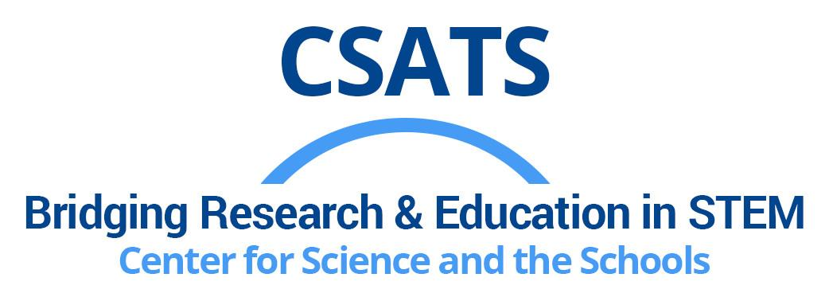
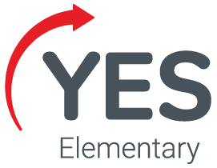
Teaching Elementary Engineering:
A Workshop for Teacher Educators

Pennsylvania has adopted new Integrated Standards for Science, Environment, Ecology, Technology, and Engineering!

Are you an elementary teacher educator?
Would you like to:
- Learn about K-5 engineering education by engaging with curricular materials aligned with the new PA standards?
- Help other elementary teachers introduce engineering to their students?
- Network with teacher educators to think about engineering education?

Join us and receive: | You commit to:
- 2 days of professional learning about engineering, STEM, featuring Youth Engineering Solutions (YES) curricula  - ACT 48 credit  - $1000 stipend ($500/day)  - $3000 YES curricula voucher for your region | - Offering professional learning about engineering with YES materials for 10+ elementary teachers in your region  - Networking with other educators  - Providing access to the YES curricular materials
More information about Youth Engineering Solutions (YES) curricula: https://yes.psu.edu

Workshops:
April 25-26, 2024 – Arcadia University, Glenside, PA
May 26-27, 2024 – Arcadia University, Glenside, PA

Enrollment is limited to 10 educators. Participants will be notified April 15, 2024.
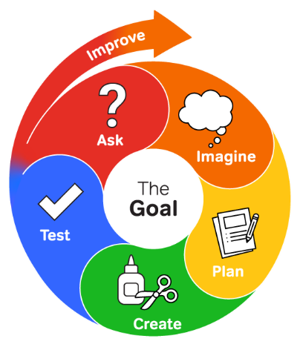
Register here

Offered by:
Center for Science and the Schools
Youth Engineering Solutions (YES)

For more information contact Matt Johnson:
mjohnson@psu.edu
814-863-6607

Engineering Design Process
Funded by a PA SMART grant from Pennsylvania Department of Education

