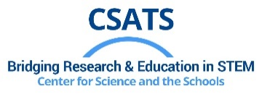
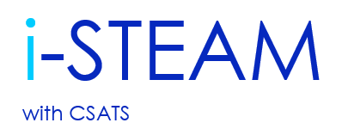

Exploring the Universe: An Introduction to Multi-Messenger Astronomy for Educators

Kohta Murase (Department of Astronomy and Astrophysics)
Matt Johnson (Center for Science and the Schools)

May 9, 2023 (9:00 am – 3:00 pm)
301D Huck Life Sciences Building
Penn State University

The answers to some of the most fundamental questions of our universe can be found by studying the behavior of systems in other galaxies. New technologies have emerged to collect more and more data from cosmic explosions that teach us about the life cycle of stars, the formation of galaxies, and how elements are formed and recycled. However, astronomers cannot perform controlled experiments. This workshop uses a few classic astronomy phenomena to demonstrate how astronomers use the laws of physics, chemistry and math to better understand our universe. Teachers will also learn about Dr. Murase’s innovative research. All teachers are welcome, but content is most applicable to physics, physical science, astronomy, chemistry, and math teachers, particularly those who teach about elements, radiation, and gravity.
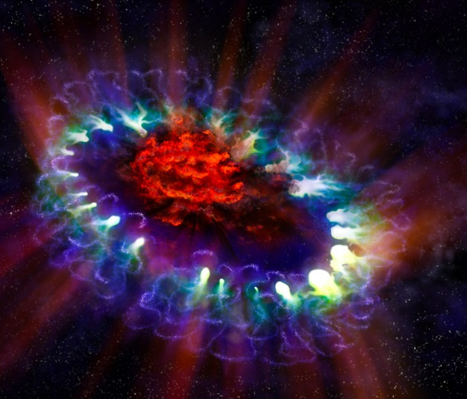
Target Audience: Teachers of students grades 6-12

This workshop and six ACT 48 hours are provided FREE to all educators
Key PA STEELS Standards: 3.2.9-12.A; 3.3.9-12.B; 2.2.9-12.C; 3.3.9-12.W
A continental breakfast and lunch are provided by the Center for Science and the Schools (CSATS). Maximum enrollment is 24 register online now to reserve a spot online today.

For more information email Matt Johnson at mjohnson@psu.edu or call 814-863-6607.

Sponsored by:
The Center for Science and the Schools and National Science Foundation (AST: 2108466)
